# 

# FOOD BLOG REPORT

### A MINI PROJECT REPORT

#### Submitted by

#### Group/Team No: G20/T7

**AMAN KUMAR, 2310991770**

**AMISHA PUNDIR, 2310991771**

**AMRIT KAUR, 2310991772**

#### in partial fulfillment for the award of the degree of

## **BACHELEOR OF ENGINEERING**

## 

## ***in***

COMPUTER SCIENCE & ENGINEERING



**CHITKARA UNIVERSITY**

**CHANDIGARH-PATIALA NATIONAL HIGHWAY**

**RAJPURA (PATIALA) PUNJAB-140401 (INDIA)**

##### **November/2023**

**ABSTRACT**

Embark on a delectable voyage with our food blog, "Culinary Chronicles," where every post is a flavourful narrative that transcends the boundaries of the kitchen. Our blog is a vibrant canvas where passion for food meets the art of storytelling, creating a sensory experience that goes beyond taste alone. Immerse yourself in a world of diverse cuisines, each dish unravelling its own tale. From the sizzling streets of Southeast Asia to the comforting kitchens of Italian Nona’s, Culinary Chronicles invites readers to explore the cultural tapestry woven into each recipe. We believe that every plate has a story to tell, and we are here to narrate those tales. Our seasoned bloggers and culinary enthusiasts share not only recipes but also the personal anecdotes, cultural histories, and the love that goes into creating memorable meals. Whether you're a seasoned chef or a novice in the kitchen, our blog caters to all palates, providing step-by-step guides, cooking tips, and the inspiration you need to turn your kitchen into a canvas of creativity. Join us on this gastronomic journey, where we celebrate the joy of cooking, the beauty of diverse flavours, and the stories that bring food to life. Culinary Chronicles is not just a food blog; it's a celebration of the shared human experience found around a dining table, connecting us through the universal language of food. From the sizzling streets of Southeast Asia to the comforting kitchens of Italian Nona’s, Culinary Chronicles invites readers to explore the cultural tapestry intricately woven into each recipe. We firmly believe that every plate has a story to tell, and we are here to narrate those tales. Our seasoned bloggers and culinary enthusiasts share not only recipes but also personal anecdotes, cultural histories, and the love that goes into creating memorable meals. Whether you're a seasoned chef or a novice in the kitchen, our blog caters to all palates. We provide step-by-step guides, cooking tips, and the inspiration you need to turn your kitchen into a canvas of creativity. Join us on this gastronomic journey where we celebrate the joy of cooking, the beauty of diverse flavours, and the stories that bring food to life. Culinary Chronicles is more than just a food blog; it's a celebration of the shared human experience found around a dining table, connecting us through the universal language of food. Through our narratives and recipes, we aim to foster a sense of community, inviting readers to join us in the exploration of the rich and varied world of culinary delights. Join us at Culinary Chronicles, where every post is a delectable chapter waiting to be savoured in the grand feast of life.Top of Form

**TABLE OF CONTENTS**

|  |  |  |
| --- | --- | --- |
| Sr.no | Section | Page no |
| 1) | **Introduction** | **1-2** |
| 2) | **Problem Statement** | **2-3** |
| 3) | **Technical Details** | **3-4** |
| 4) | **Key Features** | **4-5** |
| 5) | **Project Snapshots** | **5-6** |
| 6) | **Project Advantages** | **6-7** |
| 7) | **Conclusion** | **7-8** |
| 8) | **References** | **9-11** |

**1)INTRODUCTION**

“FOOD BLOG WEBSITE”

Blogging about food has become a very popular hobby in the last two to three years. Food blogs cover recipes, restaurant reviews, and every other aspect of the foodie world, and are often accompanied by gorgeous food photography. It is very easy to get into the food blogging world, as all you need is access to a blogging platform (such as Blogger, Typed or WordPress) and a love for great food. Here, the sizzle of a pan and the aroma of spices are more than just sensations; they're the opening notes to a gastronomic symphony. Join us as we explore the world through the lens of a food lover, discovering the diverse tapestry of cuisines, from street food adventures to the timeless traditions passed down through generations. Our blog isn't just a collection of recipes; it's a celebration of the artistry in every kitchen, the cultural richness on every plate, and the joy found in sharing a meal. So, pull up a chair, grab a virtual fork, and let's embark on a culinary journey together – where every post is a delicious chapter waiting to be savoured. In this culinary realm, the sizzle of a pan and the aromatic dance of spices are not just sensory experiences; they are the overture to a gastronomic symphony that unfolds with each blog post. The allure of food blogging lies in its ability to transcend the mere sharing of recipes and restaurant reviews; it is a journey that invites readers to explore the diverse and rich tapestry of the foodie world. It goes beyond the plate, weaving a narrative that encompasses everything from street food adventures to the timeless culinary traditions passed down through generations. What distinguishes our food blog is not merely a collection of recipes but a celebration of the artistry inherent in every kitchen. It is a virtual space where the cultural richness embodied in each plate takes centre stage, and the joy of sharing a meal becomes a shared experience. Through our blog, we aim to invite readers into a world where each post is not just a set of instructions but a chapter in a delectable story waiting to be savoured. Embarking on this culinary journey with us is an invitation to explore the world through the lens of a food lover. We venture beyond the confines of familiar cuisines, embracing the thrill of discovery in every bite. From the bustling streets where local vendors craft culinary wonders to the kitchens where age-old traditions come to life, our blog is a passport to a global culinary adventure.

**2) PROBLEM STATEMENT**

The project aims to address the challenge of establishing and maintaining a successful food blog in an increasingly competitive online food culture. This includes creating engaging, high-quality content, growing a dedicated readership, and effectively monetizing the blog, while also complying with legal and ethical standards. In recent years, the digital landscape has witnessed a surge in the popularity of food blogs. With the proliferation of social media and the rise of food influencers, food enthusiasts are now turning to blogs for culinary inspiration, recipes, and lifestyle content. However, this growing popularity also brings challenges for aspiring and established food- bloggers. The first key aspect of the project involves the creation of engaging and high-quality content. This extends beyond the mere provision of recipes to crafting narratives that weave together cultural, historical, and personal dimensions, transforming each dish into a compelling story. Additionally, the project will delve into the visual elements of content creation, emphasizing the importance of aesthetically pleasing photography and videography to enhance the overall appeal of the blog. Techniques such as styling, lighting, and composition will be explored to ensure that the visual representation aligns with the narrative, capturing the audience's attention and fostering a deeper connection. Building and expanding a dedicated readership form the second focal point of the project. This entails strategies for effective audience engagement, utilizing various channels such as social media platforms, newsletters, and community forums. Techniques for fostering a sense of community, responding to audience feedback, and creating a dialogue will be explored. The project will also delve into the importance of consistency in content delivery and the establishment of a unique brand identity to distinguish the blog in a crowded digital space. Monetization strategies constitute the third critical element of the project. While passion often drives individuals to initiate food blogging, the potential for generating income has turned this pursuit into a viable career option for some. The project will explore diverse avenues for monetization, including sponsored content, affiliate marketing, digital product sales, and online cooking classes. Each avenue will be examined for its merits and potential pitfalls, guiding bloggers in making informed decisions aligned with their goals and values.

**3)TECHNICAL DETAILS**

**HTML CODE:**

The following HTML code describes the structure of the webpage. First of all it has an header tag to display the name of the company which is “Online Food Shop”. The navigation bar contains tabs of “Home”, “About”, “Menu” and “Contact Us”. The navigation bar also consists of the logo of the company followed by the background image with some more details of the “Online Food Shop” along with the featured products.

**CSS:**

This is the stylesheet block which gives us the proper look of the webpage.

* **Header styling:** It consists of two “head” tags. We have used font-style “Ubuntu” to style the header and we also used proper colours to make some text look attractive.
* **Navigation bar styling:** It basically consists of logo styling and content styling. First of all we have considered the navigation bar as a flexbox and assigned the flex-direction to “column”. We have cantered the logo image by display: block. We have used the margin: auto property to centre the image. Then we considered the content of the navigation bar as a flexbox and then we have positioned it properly.
* **Background image styling:** We used before pseudo selectors to set the respective background images.

**JavaScript**

JavaScript code that handles a menu bar click event and uses the Scroll Reveal library for adding scroll animations to various elements on your webpage. The code toggles a class on the menu bar and the navigation bar to show/hide the menu, and it reveals different elements with scroll animation.

**Now Briefing HTML tags:**

<html>

The root element that wraps the entire HTML document.

<head>

Contains meta-information about the HTML document, such as character set, viewport settings, and links to external resources.

Meta Tags: Provide information about character set and viewport settings.

Title: Sets the title of the webpage.

<body>

Contains the content of the HTML document, including headers, paragraphs, images, forms, etc.

**Header Section**

<header>

**Represents the header of the webpage.**

Logo: Displays a logo image.

Navigation (<nav>): Contains navigation links.

Icons: Includes a menu bar icon and a contact button.

**Home Section**

<div class="home">

**Represents the main content section of the home page.**

Login Box (<div class="login-box">): Styled box containing a login form.

About Section

<div id="about" class="about">

**Represents the about section of the webpage**.

About Content (<div class="main-about">): Contains an image and text about the company.

**Quality Section**

<div class="quality">

**Represents the section about food quality.**

Quality Content (<div class="quality-content">): Contains text about food quality.

Quality Image (<div class="quality-content quality-image">): Contains an image.

Gallery Section

<div class="gallery">

**Represents the gallery section.**

Gallery Images (<div class="inner-gallery">): Contains images within the gallery.

Enjoy Our Food Section

<div class="enjoy-our-food">

**Represents a section encouraging users to enjoy the food.**

Our Menu Section

<div class="our-menu-food">

**Represents the section displaying the menu.**

Menu Items (<div class="inner-menu-food">): Contains images and text for menu items.

Before Footer Section

<div class="before">

Contains an image before the footer section.

**Footer Section**

<div class="footer">

**Represents the footer section of the webpage.**

Footer Logo (<div class="footer-logo">): Displays a logo image.

Footer Navigation (<footernav class="footer-navbar">): Contains navigation links.

**JavaScript Section**

<script>

Includes links to external JavaScript libraries (Scroll Reveal) and your custom JavaScript file (script.js). Also, there's an immediate alert on page load, which may not be desired.

**1. Duplicate ID for Phone Number:**

In HTML, the id attribute is used to uniquely identify an element. However, in your code, you have used the ID "phone number" for both the label and the text area. This can cause issues because IDs must be unique within a page. I recommended changing the second usage to a different ID, such as "phone.

**2. Form Action Placeholder:**

The action attribute in the <form> tag specifies where the form data should be sent when the user submits the form. In your code, the action is set to #, which is a placeholder URL. If you have a specific server-side script or endpoint to handle form submissions, replace # with the actual URL.

**3. CSS Styling:**

In the CSS section, you have margin: 10; and padding: 20;. The values should include units, such as pixels (px). I added px to both properties to specify the margin and padding.

**4. Accessibility Improvements:**

In the <body> section, you have set a background image using background-image: url(bmi9.webp);. It's a good practice to provide alternative text for background images for accessibility purposes. I recommended adding an alt attribute to the <img> tag with a brief description of the background image

**Styling Codes (CSS)**

**1. Global Styles:**

@import url('https://fonts.googleapis.com/css2?family=Roboto:wght@300;400;500;700&display=swap');: Imports the Google Fonts library to use the Roboto font in different weights.

root: Defines global variables (CSS custom properties) that can be used throughout the stylesheet.

**2. General Styles:**

Applies styles to all elements on the page.

html: Sets the base font size and enables smooth scrolling behavior.

header: Styles for the website header, including positioning, background color, and logo styling.

navbar: Styles for the navigation bar, including color, hover effects, and transitions.

icons: Styles for social icons, initially hidden.

home, .about, .quality, .gallery, .enjoy-our-food, .our-menu-food, .before, .footer: Styles for different sections of the website.

**3. Home Section Styles:**

home-inner-content, .home-image, .home-text-content: Styles for organizing content in the home section.

Keyframes (@keyframes mymove): Animation for moving the home image.

**4. About Section Styles:**

main-about, .about-content, .about-inner-content, .about-text-content: Styles for organizing content in the about section.

**5. Quality Section Styles:**

quality, .main-quality, .main-inner-quality, .quality-content, .qulity-image: Styles for organizing content in the quality section.

**6. Gallery Section Styles:**

gallery, .main-gallery, .inner-gallery: Styles for organizing and formatting the gallery section.

**7. Enjoy Our Food Section Styles:**

enjoy-our-food, .food-main-content: Styles for organizing content in the "Enjoy Our Food" section.

**8. Our Menu Food Section Styles:**

our-menu-food, .\main-menu-food, .inner-menu-food, .menu-food-content, .menu-food-text: Styles for organizing content in the "Our Menu Food" section.

**9. Before Section Styles:**

before: Styles for the "Before" section.

**10. Footer Styles:**

footer, .main-footer, .footer-navbar: Styles for organizing content in the footer section.

**11. Media Query (Max-width: 767px):**

Adjusts styles for smaller screens, such as increased padding in the header, displaying social icons, and modifying the layout of various sections for better responsiveness.

**Python Script Integration**

The HTML code defines the structure of a web page titled "Falling Thunder" and integrates the PyScript library to enable Python scripting within the document. In the head section, essential metadata is provided, including the document title, character encoding (UTF-8), and viewport settings for responsive design. Additionally, external resources are linked to enhance functionality—a stylesheet (`pyscript.css`) and a JavaScript file (`pyscript.js`) from the PyScript library. These resources are retrieved from the specified URLs, and the JavaScript file is marked with the 'defer' attribute, indicating that it should be executed after the HTML document has been parsed. Moving to the body section, the integration of PyScript begins with the `<py-config>` tag, pointing to a configuration file (`pyscript.toml`). This file likely contains settings and configurations specific to the PyScript library. Subsequently, the `<py-script>` tag includes the main PyScript file (`main.py`), suggesting that this file contains the primary Python script to be executed within the web page. This structure enables the use of Python code seamlessly within the HTML document, enhancing the interactivity and dynamic features of the web page. Users implementing this code should verify the correctness of file paths and ensure that the referenced PyScript library version and external resources are available and compatible for the intended functionality.

**4)Project Snapshots**

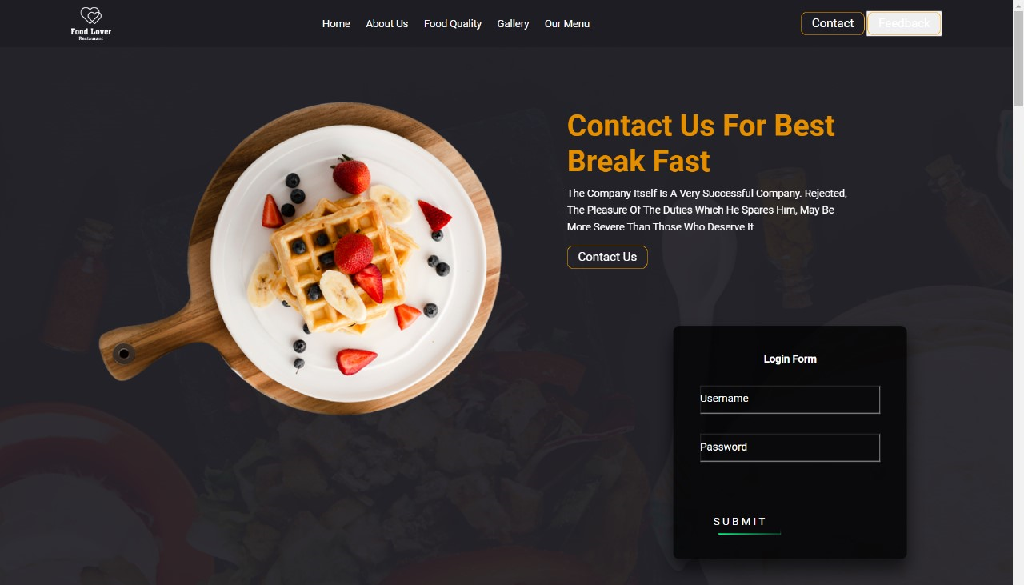

Figure 1:Home Page

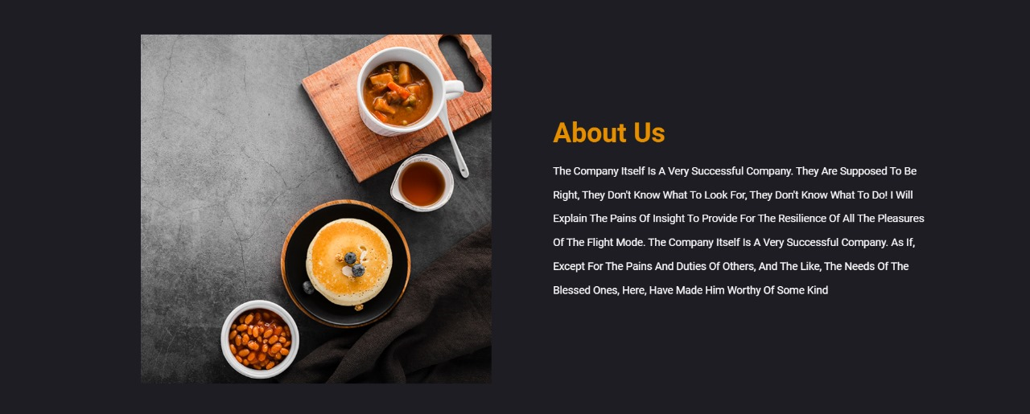

Figure 2: About Page

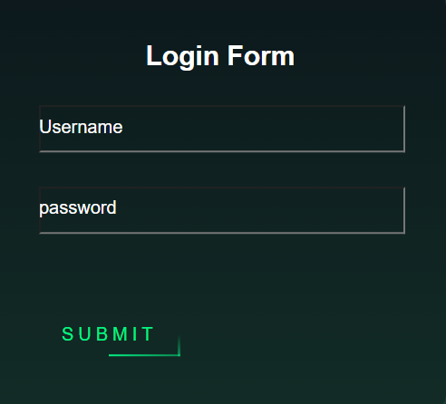

Figure 3: Login Page

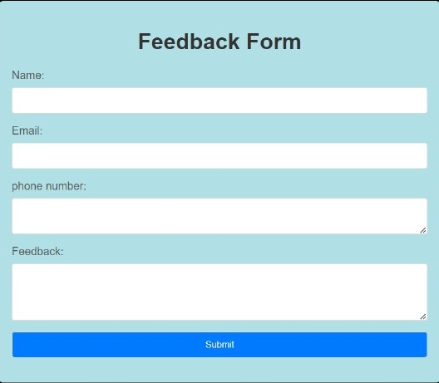

Figure 4: Feedback Page

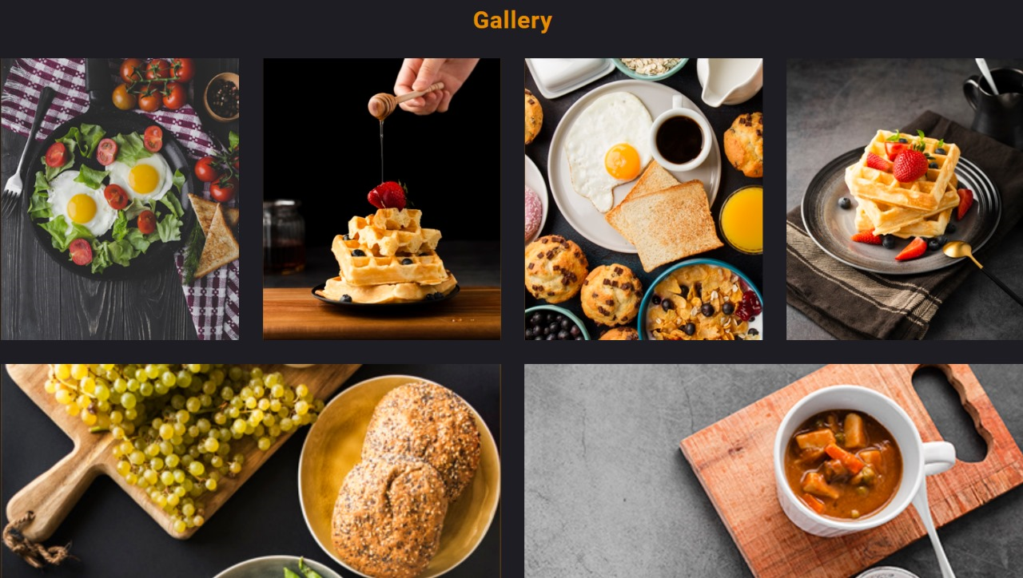

Figure 5: Gallery

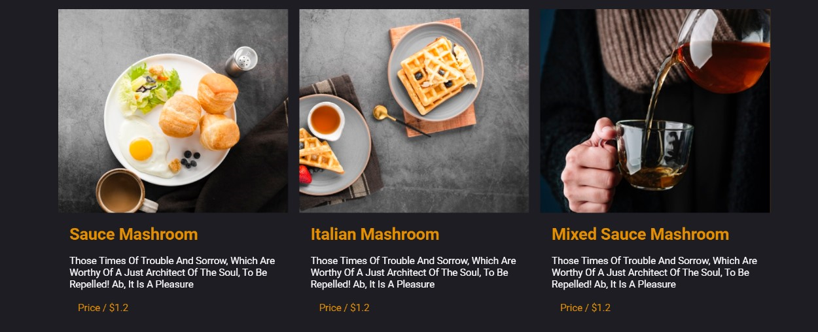

Figure 6:Menu Page

**5) KEY FEATURES**

* Printable Recipe Cards: Provide users with the option to print recipe cards, allowing them to have a handy physical copy in the kitchen while preparing meals.
* Nutritional Information: Include nutritional details for each recipe, catering to readers with specific dietary requirements and promoting transparency about the content of the dishes.
* Video Content: Integrate video content alongside written recipes for a more immersive cooking experience. Video tutorials can guide users through each step, making the cooking process more accessible.
* Personalized User Accounts: Allow users to create accounts for personalized experiences, such as saving favorite recipes, creating shopping lists, or receiving personalized recommendations based on their cooking preferences.
* Email Subscription: Implement an email subscription service to keep readers informed about new recipes, cooking tips, and other relevant content. This helps build a loyal readership and encourages repeat visits.
* Collaborations and Guest Posts: Foster a sense of community by allowing guest bloggers or chefs to contribute content. This not only diversifies the blog's content but also brings in different perspectives and expertise.
* Seasonal and Holiday Sections: Create dedicated sections for seasonal recipes and holiday-themed content to align with the time of the year and offer timely inspiration for special occasions.
* Interactive Features: Consider adding interactive elements such as polls, quizzes, or surveys to engage readers and gather feedback on their preferences or suggestions for future content.
* Recipe Ratings and Reviews: Allow users to rate and review recipes. This not only provides valuable feedback for the blogger but also assists other users in deciding which recipes to try.
* Localized Content: Tailor content to regional or local cuisines, taking into account the diverse preferences of a global audience. Include anecdotes or stories related to the cultural significance of certain dishes.

**Project Advantages**

* **Culinary Creativity:** Food bloggers have the freedom to explore their culinary creativity, experiment with ingredients, and create unique recipes that showcase their passion for cooking and eating.
* **Sharing Delicious Recipes:** Bloggers delight in sharing their favorite recipes, from mouthwatering appetizers to delectable desserts, allowing readers to recreate these dishes in their own kitchens
* **Healthy Living:** Many food bloggers focus on creating nutritious and balanced recipes, promoting healthier lifestyles through mindful eating choices.
* **Cooking Tips and Techniques:** Bloggers often share cooking tips, techniques, and hacks to help readers improve their culinary skills and become more confident in the kitchen.
* **Community Building:** Food bloggers cultivate online communities of food enthusiasts, fostering connections, discussions, and sharing experiences with like-minded individuals.
* **Generous Sharing of Knowledge:** Bloggers generously share cooking tips, techniques, and hacks to help readers improve their culinary skills and gain confidence in the kitchen
* **Vibrant Online Communities:** Bloggers actively cultivate online communities of food enthusiasts, providing spaces for connection, collaboration, and shared experiences
* **Encouraging Discussions:** Through their blogs and social media presence, they encourage discussions, shared triumphs, and challenges, fostering a sense of camaraderie among like-minded individuals

**7) CONCLUSION**

In conclusion, food blogging is a vibrant and dynamic niche within the digital landscape that offers both opportunities and challenges to those passionate about culinary exploration and sharing their gastronomic experiences. To succeed in the world of food blogging, one must navigate through the complexities of content creation, audience engagement, and monetization while adhering to legal and ethical standards. At its core, food blogging is a celebration of diverse tastes, flavours, and culinary traditions. Bloggers in this niche embark on a journey of gastronomic exploration, documenting their encounters with various cuisines, cooking techniques, and ingredients. This dynamic and visually appealing content serves not only to satiate the audience's appetite for culinary inspiration but also to foster a sense of connection and community around the shared love for food. One of the key challenges in food blogging is the intricate process of content creation. Successful food bloggers go beyond merely showcasing recipes; they tell stories through their food. Each dish becomes a narrative, weaving together the cultural, historical, and personal aspects that make it unique. The artful presentation of these stories requires not only culinary skill but also a keen eye for photography and videography, as visual appeal plays a pivotal role in capturing the audience's attention. In addition to creating compelling content, food bloggers face the ongoing challenge of audience engagement. Building and maintaining an active and loyal readership involves consistent interaction through various channels, including social media platforms, newsletters, and comments sections. Engaging with the audience goes beyond sharing recipes; it entails creating a community where followers feel heard and valued. Responding to comments, conducting polls, and even organizing live cooking sessions are strategies employed by successful food bloggers to forge a strong connection with their audience. Monetization is another crucial aspect of the food blogging landscape. While many individuals embark on this journey driven by passion, the potential for generating income has turned food blogging into a viable career option for some. Various monetization strategies exist, ranging from sponsored content and affiliate marketing to selling digital products or even launching cooking classes. However, navigating this landscape requires a delicate balance between authenticity and commercialization to maintain the trust of the audience.

**8)REFERENCES**

* https://www.epicurious.com/expert-advice
* https://asianfoodnetwork.com/en/recipes/cuisine/chinese/ngoh-hiang.html
* <https://www.epicurious.com/recipes-menus/best-cookie-recipes-chocolate-chip-raisin-peanut-butter-gallery>
* <https://smittenkitchen.com/recipes/greek/?format=photo>
* <https://www.101cookbooks.com/homemade-spice-blends/>
* <https://www.closetcooking.com/20-apple-icious-recipes/>
* <https://damndelicious.net/2020/12/18/garlic-rosemary-beef-tenderloin/>
* <https://pinchofyum.com/winter-grain-bowl-with-balsamic-dressing>
* <https://www.recipegirl.com/mixed-green-salad-with-honey-lemon-dressing/>
* https://www.sailusfood.com/kosambari-recipe-moong-dal-salad/